Lesson 5 Demo 2: Join Nodes to a Swarm

This section will guide you to:

* Join a worker node to the swarm cluster in Docker

**Step 1:** Run the following command on the **master** node and copy the *docker swarm join* command as shown in the following screenshot:

*sudo docker swarm join-token worker*

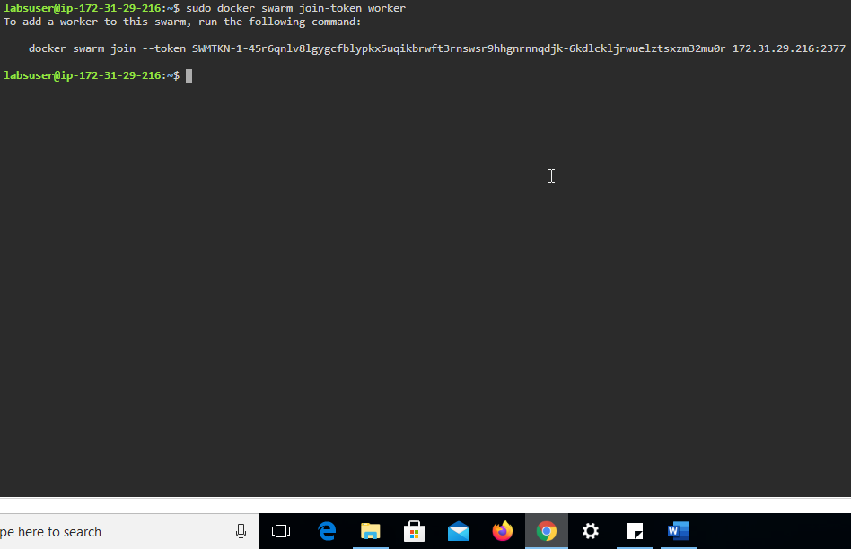

**Step 2:** Click on the **worker2** tab on the lab and navigate to the newly opened browser tab



**Step 3:** On **worker2,** join the swarm as a **worker node** using the *docker swarm join* command provided in the first step

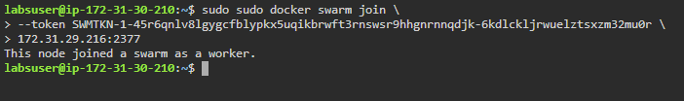

**Note:** Navigate back to the **master** node window

**Step 4:** On the **master** node, list all the nodes available in the swarm cluster

*sudo docker node ls*

